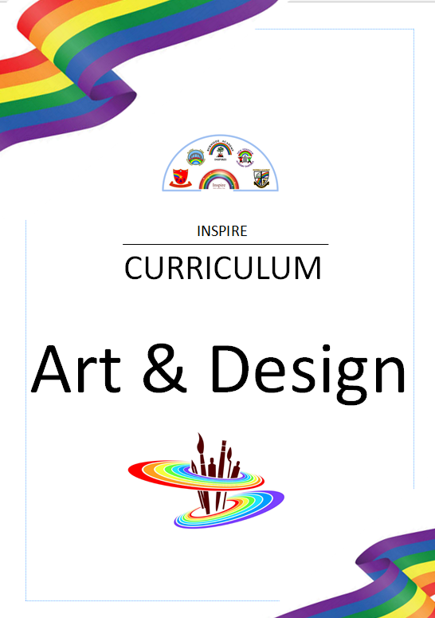

“Art has the role in education of helping children become like themselves instead of more like everyone else” – Sydney Gurewitz Clemens

Art & Design
Intent
The National Curriculum for Art and Design aims to engage, inspire, and challenge pupils. It aims to equip children with the knowledge and skills needed to experiment with and create their own works of art and design. During their time at our school, each child will have the opportunity to design, practise and develop their skills and artworks. This will evidence a progression of techniques throughout the school years.

Art and Design is an importance part of our curriculum and it is our aim to engage and inspire all children through creative planning opportunities. We believe that Art and Design encourages children to develop their creativity, nurture their imagination and provides children with a variety of ways to express their thoughts, feelings and emotions.
We aim to give all children the confidence to express themselves through a range of chosen mediums. Our children are given the opportunities to experiment with a range of different materials, to use drawing, painting and sculpting techniques to bring their ideas to life, and to practise art and design techniques when using colour, pattern, texture, line, shape, form and space. As the children progress they will be encouraged to progress their skills through experimentation and developing their control and finesse.

We want our children to know how Art & Design has contributed to our culture and understanding of our history and the world. Our children will focus on a variety of key artists and artisans and they will begin to understand the development of their particular art forms. The children will have opportunities to take inspiration from these key artists and create their own artworks in their particular styles.

Breadth of Study
The following is the breadth of study that our pupils will cover from Year One through to Year Six. All statutory requirements taken from the National Curriculum are included, and some of the content has been supported by the Chris Quigley Essentials Curriculum.
Key Stage 1 | Key Stage 2
- Use experiences and ideas as the inspiration for artwork  - Share ideas using drawing, painting and sculpture  - Explore a variety of techniques  - Learn about the work of a range of artists, artisans and designers | - Use experiences, other subjects across the curriculum and ideas as inspiration for artwork  - Develop and share ideas in a sketchbook and in finished products  - Develop and share ideas in a sketchbook and in finished products  - Improve mastery of techniques  - Learn about the great artists, architects and designers in history

Art & Design
Whole School Coverage
The following is the breadth of study that our pupils will cover from Year One through to Year Six. All statutory requirements taken from the National Curriculum are included, and the content follows Kapow Primary. Schools subscribe to Kapow and teachers will require a username and password.

 | Autumn Term | Spring Term | Summer Term
Year 1 | Drawing: Make your Mark | Painting & Mixed Media: Colour Splash | Sculpture & 3D: paper play
Year 2 | Drawing: Tell a Story | Painting & Mixed media: Life in colour | Sculpture & 3D: Clay Houses
Year 3 | Drawing: Growing Artists | Painting & Mixed Media: Prehistoric Painting | Craft and Design:  Ancient Egyptian scrolls
Year 4 | Drawing: Power Prints | Painting & Mixed media: Light & dark | Sculpture and 3D:  Mega materials
Year 5 | Drawing: I need Space | Painting & Mixed Media: Portraits | Sculpture & 3D: Interactive Installation
Year 6 | Drawing: Making my Voice Heard | Painting & Mixed Media: Artist Study | Craft & Design: Photo opportunity

