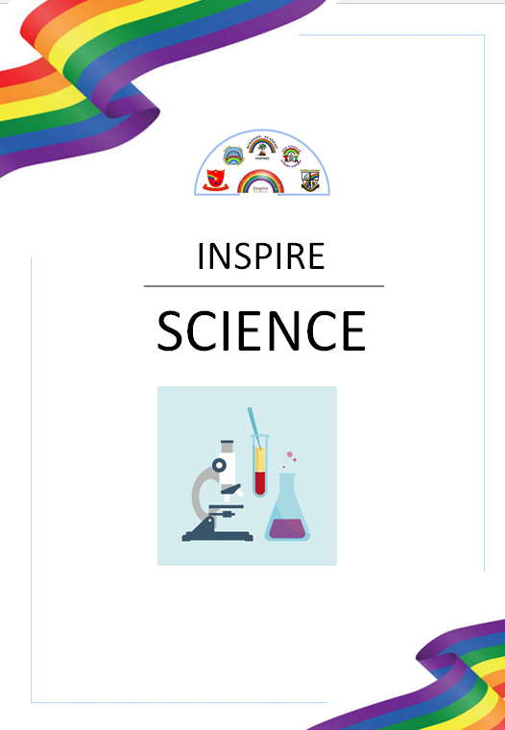

“The Science of today is the Technology of tomorrow” – Edward Teller

Science

Intent
At Inspire, we want our children to develop their scientific knowledge through carefully planned exciting Science opportunities. Our Science sessions aim to embed previous learning and deepen understanding. We aim to support children to develop an understanding of the process and methods of Science by providing a range of Scientific enquiries, investigations and questions to help them explore the world around them. We hope to develop and nurture our children’s curiosity by not only following the National Curriculum, but also following their questions and interests to develop a love, passion and appreciation for Science.
Our intention throughout school is to develop their understanding of scientific ideas by using different types of scientific enquiry to answer their own questions, including observing changes over a period of time, noticing patterns, grouping and classifying things, carrying out simple comparative tests, and finding things out using secondary sources of information. During their time at New Penshaw, we aim to equip children with the knowledge required to use and implement Science today, tomorrow and for their futures.

Breadth of Study
The following is the breadth of study that our pupils will cover from Year One through to Year Six. All statutory requirements taken from the National Curriculum.

Key Stage 1 | Key Stage 2
Working scientifically  Across all year groups scientific knowledge and skills should be learned by working scientifically. (This is documented in the Essentials for progress section.)  BIOLOGY  Plants  • Identify, classify and describe their basic structure.  • Observe and describe growth and conditions for growth.  Habitats  • Look at the suitability of environments and at food chains.  Animals and humans  • Identify, classify and observe.  • Look at growth, basic needs, exercise, food and hygiene.  All living things*  • Investigate differences.  CHEMISTRY  Materials  • Identify, name, describe, classify, compare properties and changes.  • Look at the practical uses of everyday materials  PHYSICS  Light*  • Look at sources and reflections.  Sound*  • Look at sources.  Electricity*  • Look at appliances and circuits.  Forces  • Describe basic movements.  Earth and space  • Observe seasonal changes. | Working scientifically  Plants  • Look at the function of parts of flowering plants, requirements of growth, water transportation in plants, life cycles and seed dispersal.  Evolution and inheritance  • Look at resemblance in offspring.  • Look at changes in animals over time.  • Look at adaptation to environments.  • Look at differences in offspring.  • Look at adaptation and evolution.  • Look at changes to the human skeleton over time.  Animals and humans  • Look at nutrition, transportation of water and nutrients in the body, the muscle and skeleton system of humans and animals.  • Look at the digestive system in humans.  • Look at teeth.  • Look at the human circulatory system.  All living things  • Identify and name plants and animals  • Look at classification keys.  • Look at the life cycle of animals and plants.  • Look at classification of plants, animals and micro organisms.  • Look at reproduction in plants and animals, and human growth and changes.  • Look at the effect of diet and exercise and drugs. Across all year groups scientific knowledge and skills should be learned by working scientifically.  Biology  Rocks and fossils  • Compare and group rocks and describe the formation of fossils. States of matter  • Look at solids, liquids and gases, changes of state, evaporation, condensation and the water cycle.  Materials  • Examine the properties of materials using various tests. • Look at solubility and recovering dissolved substances.  • Separate mixtures.  • Examine changes to materials that create new materials that are usually not reversible.  Light  • Look at sources, seeing, reflections and shadows. • Explain how light appears to travel in straight lines and how this affects seeing and shadows.  Sound  • Look at sources, vibration, volume and pitch.  Electricity  • Look at appliances, circuits, lamps, switches, insulators and conductors.  • Look at circuits, the effect of the voltage in cells and the resistance and conductivity of materials.  Forces and magnets  • Look at contact and distant forces, attraction and repulsion, comparing and grouping materials.  • Look at poles, attraction and repulsion.  • Look at the effect of gravity and drag forces.  • Look at transference of forces in gears, pulleys, levers and springs. Earth and space  • Look at the movement of the Earth and the moon.  • Explain day and night.

Science
Whole School Coverage
The following grid shows the coverage of Science units across the Primary age range at our school. Each unit has been carefully and progressively planned to build upon pupil’s historical knowledge, making relevant links to their lives and local area where possible. Within each unit, pupils will learn knowledge about different categories and these will be linked to key historical concepts.
 | Autumn 1 | Autumn 2 | Spring 1 | Spring 2 | Summer 1 | Summer 2
Year 1 | Seasonal Changes | Everyday Materials | Sensitive Bodies | Comparing Animals | Introduction to Plants | Making Connections
Year 2 | Habitats | Microhabitats | Uses of everyday Materials | Life cycles & Health | Plant Growth | Making Connections
Year 3 | Movement & Nutrition | Forces & Magnets | Rocks & Soil | Light & Shadows | Plant reproduction | Making connections
Year 4 | Digestion & Food | Electricity & Circuits | States of Matter | Sound & Vibrations | Classification & Changing Habitats | Making Connections
Year 5 | Mixtures & Separation | Properties & Changes | Earth & Space | Life cycles & Reproduction | Imbalanced Forces | Human timeline | Making Connections
Year 6 | Classifying big and small | Light and reflection | Evolution & Inheritance | Circuits, Batteries and switches | Circulation & exercise | Making Connections



