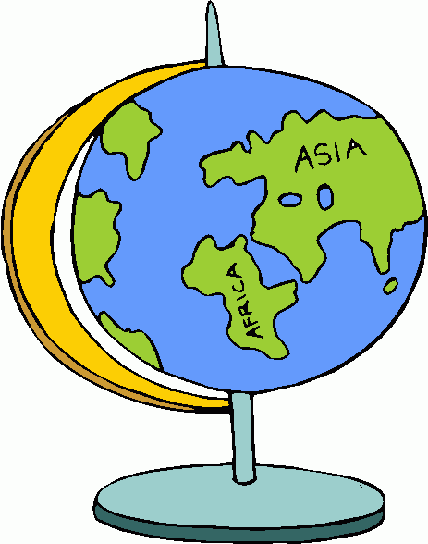
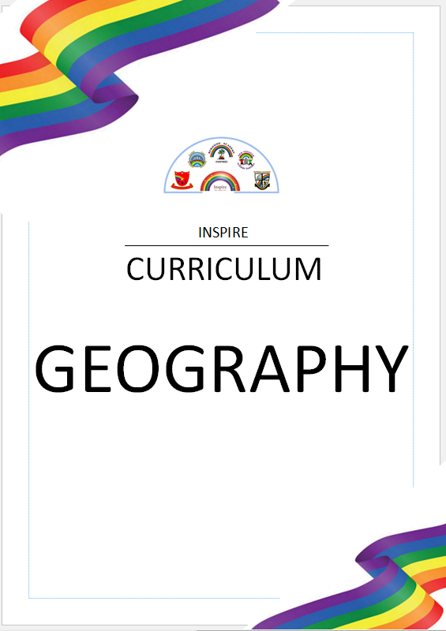

“Geography is a subject which holds the key to the future” – Michael Palin

Geography
Intent
At Inspire Multi-Academy Trust it is our intention that Geography will inspire pupils with a curiosity and fascination about the world. We aim to offer opportunities for children to explore and understand the human and physical world, promoting their interest and understanding about locations, physical and human features, diversity and geographical techniques. Through this, children will have a greater understanding of their place in the world, their rights, responsibilities and the impact they have.
It is our intention that the Geography curriculum will be both stimulating and motivating in order to capture the pupil’s curiosity and fuel their motivation to learn, by providing them with exciting learning opportunities so as they enjoy acquiring and developing their skills and knowledge and perceive the world as an interesting place.

Breadth of Study
The following is the breadth of study that our pupils will cover from Year One through to Year Six. All statutory requirements taken from the National Curriculum are included.

Key Stage 1 | Key Stage 2
- Investigate the World’s continents and oceans  - Investigate the countries and capital cities of the United Kingdom  - Compare & contrast a small area of the United Kingdom with that of a non-European country  - Explore weather and climate in the United Kingdom and around the world | - Locate the world’s countries, with a focus on Europe and countries of particular interest to pupils  - Locate the world’s countries, with a focus on North America and countries of particular interest to pupils  - Identify key geographical features of the countries of the United Kingdom, and show an understanding of how some of these aspects have changed over time  - Locate the geographic zones of the world  - Understand the significance of the geographic zones of the world



Whole School Coverage
 | Autumn Term | Spring Term | Summer Term
Year 1 | What’s it like here? | What is the weather like in the UK? | What is it like to live in Shanghai?
Year 2 | Would you prefer to live in a hot or a cold place? | Why is our world wonderful? | What is it like to live on the coast?
Year 3 | Why do people live near volcanoes? | Who lives in Antarctica? | Are all settlements the same?
Year 4 | Why are rainforests important to us? | Where does our food come from? | What are rivers and how are they used?
Year 5 | What is life like in the Alps? | Why do oceans matter? | Would you like to live in the Desert?
Year 6 | Why does population change? | Where does our energy come from? | Can I carry out an independent fieldwork enquiry?
The following grid shows the coverage of Geography units across the Primary age range at our school. We use Kapow Primary curriculum for Geography as each unit has been carefully and progressively planned to build upon pupil’s Geographical knowledge, making relevant links to their lives and local area where possible, and includes progressive fieldwork tasks that are interwoven through the whole curriculum.

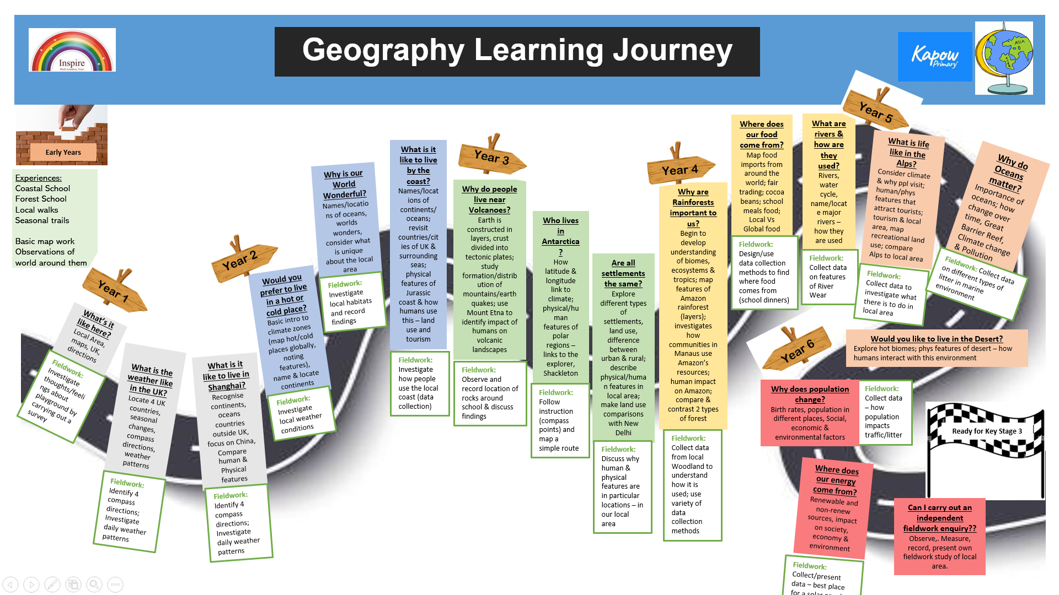
Fieldwork:
Collect/present data – best place for a solar panel non the school grounds

