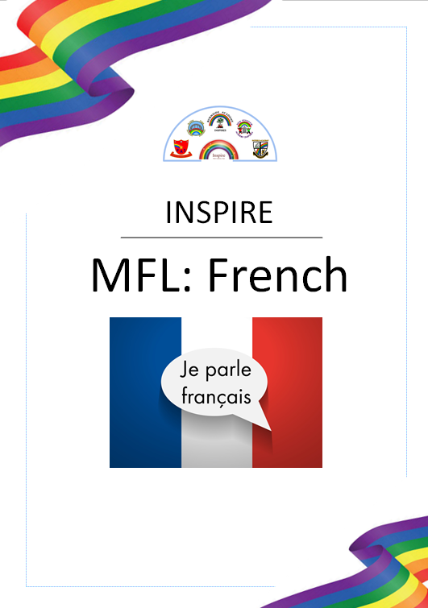

“A different language is a different vision of life” – Federico Fellini

MFL: French
Intent
At Inspire, the core language taught in Key Stage Two is French. It is the intention that all children in KS2 will access first quality teaching of French in order to adequately prepare and lay the foundations for secondary education. We wish to instil and foster pupil’s curiosity and deepen their understanding of the world beyond the United Kingdom opening up their knowledge experiences to other cultures.
Our aims in teaching French for our children are that learners will:
- Develop resilience in language learning as well as enjoyment of it through a challenging scheme of work
- Acquire language learning strategies for memorisation and retrieval as well as for listening, reading and understanding
- Speak confidently, engage in conversations and build on a knowledge of vocabulary and basic language structures
- Develop the skill of how to use a bi-lingual dictionary to decode unfamiliar language
- Recognise some of the language patterns of French and how these differ or are similar to English
- Appreciate and be able to copy the sound of the language at text level through songs, stories and rhymes
- Have a deeper understanding of cultural differences and similarities
- Demonstrate good progress in learning French and meet the targets set within the Key Stage 2 Languages Programme of Study set by the National Curriculum

Breadth of Study
Key Stage 2
Pupils should be taught to:
- listen attentively to spoken language and show understanding by joining in and responding
- explore the patterns and sounds of language through songs and rhymes and link the spelling, sound and meaning of words
- engage in conversations; ask and answer questions; express opinions and respond to those of others; seek clarification and help*
- speak in sentences, using familiar vocabulary, phrases and basic language structures
- develop accurate pronunciation and intonation so that others understand when they are reading aloud or using familiar words and phrases*
- present ideas and information orally to a range of audiences*
- read carefully and show understanding of words, phrases and simple writing
- appreciate stories, songs, poems and rhymes in the language
- broaden their vocabulary and develop their ability to understand new words that are introduced into familiar written material, including through using a dictionary
- write phrases from memory, and adapt these to create new sentences, to express ideas clearly
- describe people, places, things and actions orally* and in writing
- understand basic grammar appropriate to the language being studied, including (where relevant): feminine, masculine and neuter forms and the conjugation of high-frequency verbs; key features and patterns of the language; how to apply these, for instance, to build sentences; and how these differ from or are similar to English
The starred (*) content above will not be applicable to ancient languages.

MFL: French
Key Stage Two Coverage
