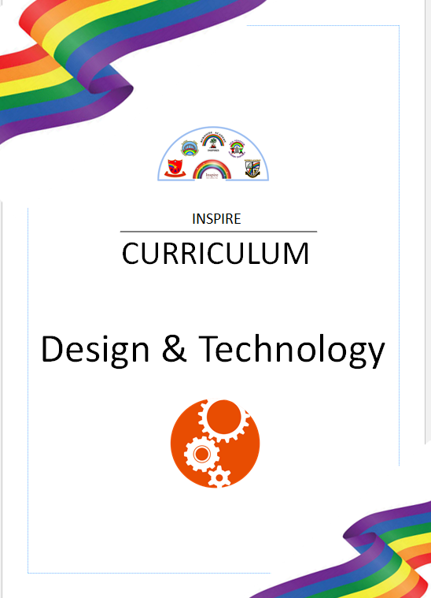
Design & Technology

Intent

Inspire Academy Trust aims to inspire pupils to be ‘inspired designers and engineers’ through facilitating innovative and creative thinkers who have an appreciation for the product design cycle through the ideation, creation and evaluation. We want pupils to develop the confidence to take risks, through drafting design concepts, modelling, and testing and to be reflective learners who evaluate their work and the work of others. Through our curriculum we aim to build an awareness of the impact of the design and technology on our lives and encourage pupils to become resourceful, enterprising citizens who will have the skills to contribute to the future design advancements.

Cooking, Food and Nutrition feature in the Autumn term at the beginning of every year group. This is because we want to ensure our children are well-informed about the foods they eat. We want to foster healthy habits and positive relationships with food for our pupils.

Breadth of Study
The following is the breadth of study that our pupils will cover from Year One through to Year Six. All statutory requirements taken from the National Curriculum are included, and some of the content has been supported by Kapow Primary – Videos, additional planning and resources to support units can be found on www.kapowprimary.com, accessed only using allocated username and passwords.
Key Stage 1 | Key Stage 2
Through a variety of creative and practical activities, pupils should be taught the knowledge, understanding and skills needed to engage in an iterative process of designing and making. They should work in a range of relevant contexts, such as the home and school, gardens and playgrounds, the local community, industry and the wider environment.  When designing and making, pupils should be taught to:  Design  design purposeful, functional, appealing products for themselves and other users based on design criteria.  generate develop, model and communicate their ideas through talking, drawing, templates, mock-ups and, where appropriate, information and communication technology.  Make  select from and use a range of tools and equipment to perform practical tasks such as cutting, shaping, joining and finishing.  select from and use a wide range of materials and components, including construction materials, textiles and ingredients, according to their characteristics.  Evaluate  explore and evaluate a range of existing products.  evaluate their ideas and products against design criteria.  Technical knowledge  build structures, exploring how they can be made stronger, stiffer and more stable.  explore and use mechanisms, such as levers, sliders, wheels and axles, in their products.  Cooking and nutrition  use the basic principles of a healthy and varied diet to prepare dishes.  understand where food comes from. | Through a variety of creative and practical activities, pupils should be taught the knowledge, understanding and skills needed to engage in an iterative process of designing and making. They should work in a range of relevant contexts, such as the home, school, leisure, culture, enterprise, industry and the wider environment.  When designing and making, pupils should be taught to:  Design  use research and develop design criteria to inform the design of innovative, functional, appealing products that are fit for purpose, aimed at particular individuals or groups.  generate, develop, model and communicate their ideas through discussion, annotated sketches, cross-sectional and exploded diagrams, prototypes, pattern pieces and computer-aided design.  Make  select from and use a wider range of tools and equipment to perform practical tasks, such as cutting, shaping, joining and finishing, accurately.  select from and use a wider range of materials and components, including construction materials, textiles and ingredients, according to their functional properties and aesthetic qualities.  Evaluate  investigate and analyse a range of existing products.  evaluate their ideas and products against their own design criteria and consider the views of others to improve their work.  understand how key events and individuals in design and technology have helped shape the world  Technical knowledge  apply their understanding of how to strengthen, stiffen and reinforce more complex structures.  understand and use mechanical systems in their products, such as gears, pulleys, cams, levers and linkages.  understand and use electrical systems in their products, such as series circuits incorporating switches, bulbs, buzzers and motors.  apply their understanding of computing to programme, monitor and control their products.  Cooking and nutrition  understand and apply the principles of a healthy and varied

Design & Technology
Whole School Coverage
The following grid shows the coverage of D&T units across the Primary age range at our school. Each unit has been carefully and progressively planned to build upon pupil’s knowledge of Design & Technology.
 | Autumn Term | Spring Term | Summer Term
Year 1 | Structures  Forest School | Mechanisms  Wheels & axels | l Cooking & Nutrition  Fruit & Vegetables:  Making Smoothies
Year 2 | Cooking & Nutrition  A Balanced Diet: Making wraps | Textiles  Pouches | Structures  Forest School
Year 3 | Cooking & Nutrition  Eating Seasonally:  Savoury Tarts | Structures  Forest School | Mechanisms  Pneumatic toys
Year 4 | Structures  Forest School | Cooking & Nutrition  Adapting a Recipe: Making biscuits | Electrical systems  Torches
Year 5 | Cooking & Nutrition  What could be Healthier?  Making Bolognese sauce | Structures  Forest School | Textiles  Stuffed Toys
Year 6 | Cooking & Nutrition  Come Dine with Me  Design & Make a 3-course Meal | Electrical Systems  Steady hand Games | Structures  Forest School

