
Early Years Fatfield Academy
Intent
At Fatfield Academy our aim is to provide the best possible start in life that supports all children to fulfil their true potential regardless of their starting points. We believe that early learning and development is the building blocks to life long learning and therefore it is crucial we get it right. Our aim in EYFS is build strong foundations rooted in academic success as well as moral and spiritual development to become curious, life -long learners.
We place great value on the development of children as individuals and providing them with the skills, knowledge and understanding they need to prepare them for their success in KS1 and beyond. We strive to equip children with a love of learning and natural curiosity so that they become confident, independent, successful learners within an enabling environment.
We offer an aspirational curriculum which is rich in wonder and memorable experiences. We strive to provide a stimulating environment which promotes exciting opportunities, challenge, exploration, adventure and a real love of learning. We believe play is an integral part of learning and this is at the heart of our early year’s curriculum. Through purposeful interactions both directed by adults and child – initiated we are able to gain best possible outcomes for learners. Excellent relationships between children, staff and parents we recognise are key and therefore we strive to have this at the heart of learning and everything we do.
It is our intent that all children will receive the teaching of early mathematics and early reading to acquire sufficient knowledge and skills that will enable them to continue their learning journey into the primary curriculum. We aim to maximise opportunities for meaningful cross curricular links offering extended periods of play following children’s interests and ideas where ever possible.
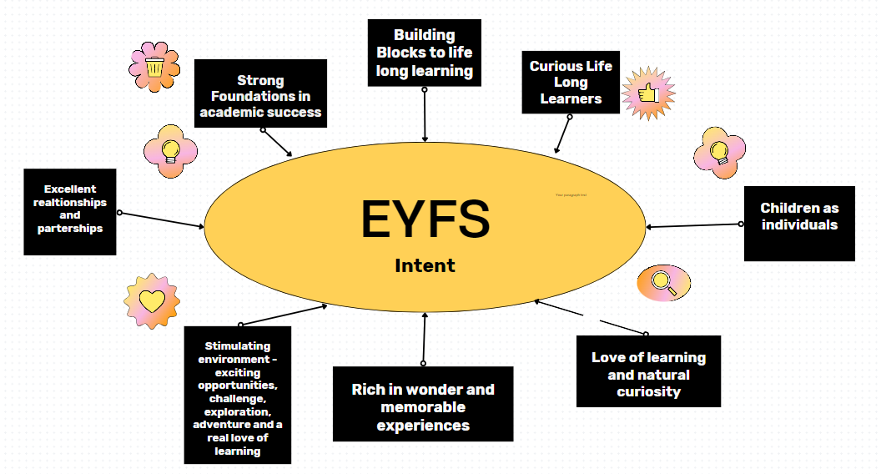

Implementation—
Our timetable and daily routine are carefully structured so that children have a balance of unstructured play opportunities as well as directed teaching of daily Maths, Phonics and English. A daily focused key group session allows staff to check for understanding, identifying and respond to misconceptions quickly and provide real-time feedback which results in strong acquisition of new learning.
At Fatfield Academy our early years practice is underpinned by the four guiding principles set out in the Early Years Framework (DfE, 2020). These are:
• Unique Child – Every child is unique child who is constantly learning and can be resilient, capable, confident and self-assured.
• Positive Relationships – Children learn to be strong and independent through positive relationships.
• Enabling Environments – Children learn and develop well in enabling environments, in which their experiences respond to their individual needs and there is a strong partnership between practitioners and parents and carers.
• Learning and Development – Children develop and learn in different ways. The framework covers the education and care of all children in early year’s provision, including children with special educational needs and disabilities.
Our Early Years Curriculum encompasses the seven areas of development set out in Development Matters (DfE, 2021): personal, social and emotional development, communication and language, physical Development, literacy, maths, understanding the world and expressive arts and design. It is taught through topics which are enriched through real life experiences and enabled through trips and visitors. Topics are supported by quality core texts and artefacts which are chosen carefully to encourage children's speech, language and communication development. The curriculum remains flexible to enable us to respond to children’s interests and needs and ensure it remains stimulating to our cohorts of children.
We prioritise creating a ‘language rich’ environment using songs, nursery rhymes, stories and providing time for quality interactions between adults and between peers. Trained staff ensure that interactions are positive and timely allowing children to flourish and gather words at pace in order to become confident communicators. Children are encouraged to become early readers through enjoyment of books, the systematic teaching of phonics and our use of core books. The children learn nursery rhymes and develop their mathematical thinking through direct teaching and exploration. We want our children to become confident mathematicians who can apply what they have learnt to real life experiences.
Our school environment has been developed to provide the opportunity to learn both indoors and outdoors with time to engage in ‘exploration’ through planned experiences. Children’s knowledge and skills are developed through a wide range of practical and sensory experiences in our mud kitchen, sandpit and natural areas. The children are supported to learn to work together, manage their feelings and ask questions through skilled adult facilitated play. In early years our environment, routines and interactions are planned for and intentional.
As part of the teaching and learning process, children are assessed in relation to their progress towards Development Matters and the Early Learning Goals. These judgements are made based on accumulative observations and in-depth knowledge of the children acquired through ongoing assessment. These ongoing assessments are used to inform planning and next steps in teaching and learning for all children throughout the year. Staff meet weekly to discuss children’s progress and plan next steps in learning.
Strong partnerships with parents and carers are created through our open-door policy where staff listen carefully to the development and home experiences of the child as well as sharing of their home to school World Book. Parents receive regular curriculum information through our school website, newsletters, social media and knowledge organisers. A range of workshops are delivered throughout the year to help parents support their child’s learning e.g. phonic meetings.
At Fatfield Academy we meet the welfare requirements laid down in the Statutory Framework for the Early Years Foundation Stage and actively safeguard and promote the welfare of all our children.
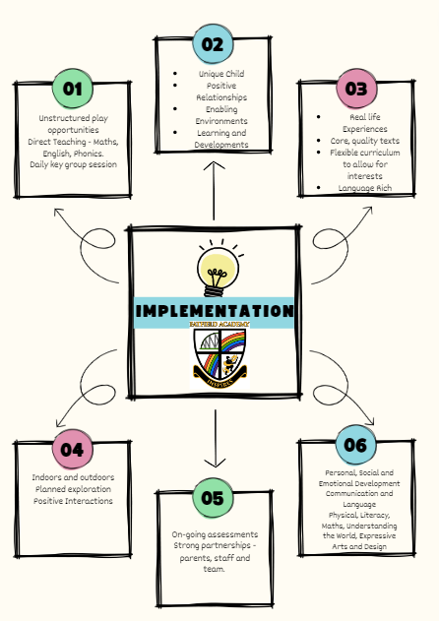
Impact
Our curriculum needs to meet the needs of our children, including our disadvantaged pupils and those with SEND, we therefore spend time looking at and evaluating how children learn. This is achieved through talking to the children, looking at their work, observing their learning experiences and analysing data. Staff use on-going observational assessment to identify children’s starting points and plan experiences which ensure progress. This information is tracked through iTRACK which enables us to measure starting points and progress termly. During each assessment window, three times a year, staff update the progress children have made onto iTRACK which allows us to assess progress, the impact of teaching and evaluate next steps. Children make excellent progress from their own on entry starting points in the seven areas of development. They have good early reading and maths skills which equips them to be school ready and develop their knowledge and skills across the primary curriculum. We strive to ensure that children attain the national expectation for good level of development by the end of Reception.

