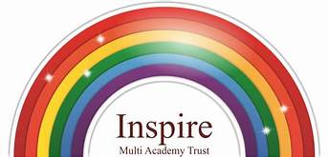EYFS – Writing Long Term Plan
 | Writing:
 |  |  | Emergent writing | Composition |  | Spelling | Handwriting
 | Autumn 1 |  | Autumn 2 | Spring 1 |  | Spring 2 | Summer 1 | Summer 2
Nursery: 3 and 4 Year Olds | Enjoy drawing freely. |  | Add some marks to their drawings, which they give meaning to. Makes marks on their picture to stand for their name. | Use some of their print and letter knowledge in their early writing: writing a pretend shopping list that starts at the top of the page; write ‘m’ for mummy. |  | Write some or all of their name. | Write some letters accurately. | Writes own name.  Write some letters accurately.
Dough Disco | Squeeze |  | Splat | Roll |  | Ball It | Finger Dive | Finger Piano
Squiggle While You Wiggle | Up and Down Movement |  | Upwards / Downwards Lines | Side to Side Lines |  | Wavy Lines | Zig Zag Lines | Arches
Reception: 4 and 5 Year Olds | Baseline assessment through: malleable, pencil grip noted.  Big Moves: core strength and stability.  Squiggle Wiggle: co-ordination, gross and small movements with scarves / chunky crayon  Intervention for those not accessing the Nursery level patterns.  Emergent Writing:  Develop listening and speaking skills in a range of contexts. Aware that writing communicates meaning. Give meaning to the marks they make. Write their name copying it from a name card or try writing from memory.  Composition: use talk to link ideas, clarify thinking and feelings. Understands thoughts can be written down.  Spelling: orally segment sounds in simple words. Write their name from card or memory.  Handwriting: know print carries meaning, is read from left to right and top to bottom.  Draws circles and lines. |  | Dough Disco continuing weekly with malleable area now including clay.  Emergent writing:  Copies adult writing behavior e.g. messages on a white board. Makes marks and drawings using increasing control. Know there is a sound/symbol relationship. Use some recognizable letters. Write letters and strings, sometimes in clusters like words. Beginning to form some recognizable letters from Phase 2.  Composition: Orally compose a sentence and hold it in memory before attempting to write it.  Spelling: orally spell vc and cvc words by identifying the sounds.  Writes own name independent.  Handwriting: form letters from their name correctly. Recognizes that after a word there is a space. Focus on modelling a comfortable pen grip. | Dough Disco: now used as intervention.  Emergent writing: use appropriate letters for initial sounds.  Composition: Orally compose a sentence and hold it in memory before attempting to write it and use simple conjunctions.  Spelling: Spell to write vc and cvc words independently using Phase 2 graphemes.  Handwriting: shows a dominant hand. Write from left to right and top to bottom. Begin to form recognizable letters. Focus on modelling and using the tripod grip when writing, painting etc. able to trace vertical lines and working on improving anti-clockwise movements.  Children are learning to control their letter size.  Remind children about posture when working at tables e.g. feet flat, forearms on tables. |  | Emergent writing: build words using letter sounds in writing.  Composition: use talk to organize describe events and experiences. Begin to write a simple sentence with support.  Spelling: spell to write vc, cvc and cvcc words independently using Phase 2 and 3 graphemes. Spell some common irregular words to, the, I, no, go independently.  Handwriting: holds a pencil effectively to form recognizable letters. Knows how to form clear ascenders and descenders. Focus on developing a comfortable way of writing – tripod pencil grip, position on paper, writing left to right. Anticlockwise movements focused: children should be able to retrace vertical lines. | Emergent writing: continue to build on knowledge of letter sounds to build words in writing. Use writing in play. Use familiar words in their writing.  Composition: write a simple sentence with a full stop.  Spelling: spell words drawing on knowledge on known grapheme correspondence. Make phonetically plausible attempts when writing more complex unknown words.  Handwriting: form most lower case letters correctly, starting and finishing in the right place, going the right way round and correctly orientated. Include spaces. | Emergent writing: show awareness of the different audience for writing.  Write short sentences with words showing letter sound correspondence using capital letter and full stop.  Composition: Write a simple narrative in short sentences with known letter sound correspondence using capital letter and full stop. Write different text forms for different purposes (lists, stories, and instructions) begin to discuss features of their own writing e.g. what kind of story they have written.  Spelling: spell words by drawing on knowledge of known grapheme correspondences. Make phonetically plausible attempts when writing more complex unknown words e.g. ccvcc using phase 4.  Spell irregular common tricky words e.g. he, she, we, be, me independently.  Handwriting: Use pencil confidently to write letters that can be clearly recognized and form some capitals correctly. Children use finger spaces between their words independently and are able to read their work.
Squiggle While you Wiggle | Arches, circles and spirals |  | Spirals and figure of 8 (vertical and horizontal) | Squares, diagonal lines, triangles. |  | Squiggle used as an intervention
Writing Stages

Pre-Phonemic Stage
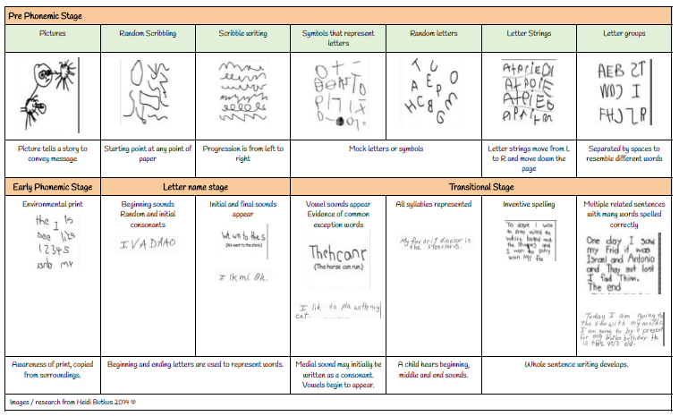
Pencil Control Development – Development of a tripod grasp

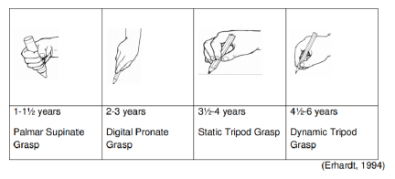
A child should be able to use a static or dynamic tripod grasp for writing. That means that: the pencil is held between the tips of the thumb, index and middle fingers. The pencil is held in a relaxed way without too much pressure on the shaft of the pencil. The pencil rests on the hand between the thumb and the index finger.

Writing: Transcription handwriting: letter formation / placement and positioning

Intergrated objectives |  | Physical Development  3 / 4 year olds:  - Use large – muscle movements to wave flags and stramers, paint and make marks.  - Use one handed toolds and equipment, for example, making snips in paper with scissors.  - Use a comfortable gripwith good control when holding pens and pencils.  - Shows preference for a dominant hand.  Reception:  Develop their small motor skills so that they can use a range of tools competently, safely and confidently. Suggested tools: pencils for drawing nd writing, paintbrushes.  - Use their core muscle strength to achieve a good posture when sitting at a table or sitting on the floor.  ELG: Hold a pencil effectively in prepartion for fluent writing – using the tripod grip in almost all cases. |  |  | Literacy  3 / 4 year olds:  - Write some letters accurately.  Reception:  - Form lower case and capital letters correctly  ELG:  - Writes recognisable letters, most of which are correctly formed.

Writing: Composition; planning, writing and editing

Integrated objectives | Communication and language:  3 / 4 year olds:  - Know many rhymes, be able to talk about familiar books, and able to tell a long story.  Reception:  - Learns new vocab.  - Articulates their ideas and thoughts in well-formed sentences.  - Describes events in some detail.  - Uses talk to help work out problems and organize thinking and activities. Explain how things work and why they might happen.  - Listen to and talk about stories to build familiarity and understanding.  - Re-tell a story, once they have developed a deep familiarity with the text; some as exact repetition and some in their own words.  - Use new vocabulary in different contexts.  - Listen to and talk about selected non-fiction to develop a deep familiarity with new knowledge and vocabulary. | Literacy:  3 / 4 year olds:  - Engage in extended conversations about stories, learning new vocabulary.  - Use some of their print and letter knowledge in their early writing e.g. pretend shopping list.  - Writes some or all of their name.  - Writes some letters correctly.  Reception:  - Form lowercase and capital letters correctly.  - Spell words by identifying the sounds and then writing the sound with the letters.  - Write short sentences with words with known letter sound correspondences using a capital letter and a full stop.  - Re-read what they have written to check it makes sense.  ELG – Writing:  Write recognisable letters, most of which are correctly formed. Spell words by identifying sounds in them and representing the sounds with a letter or letters. Write simple phrases and sentences that can be read by others. | Expressive Art and Design:  3 / 4 year olds:  - Begin to develop complex stories using small world equipment, like animal sets.  Reception:  - Develop storylines in their pretend play.  ELG: Being Imaginative and Expressive  - Invent, adapt and recount narrative and stories with peers and teachers.

Writing: Transcription Spelling: Spelling Rules

Integrated objectives | Literacy:  3 / 4 year olds  - Use some of their print and letter knowledge in their early writing. | Literacy:  Reception:  - Spell words by identifying the sounds and then writing the sound with the letter/s.

Writing: Composition: awareness of Audience, Purpose and Structure

Integrated objectives  NELI sessions | Communication and Language  3 / 4 Year olds  - Use a wider range of vocab  - Be able to express a point of view and to debate when they disagree with an adult or a friend, using words as well as actions.  - Can start a conversation with an adult or a friend and continue it for many turns.  - Use talk to organize themselves and their play.  Reception:  - Learn new vocabulary  - Use new vocab throughout the day.  - Describe events in some detail.  - Use talk to help work out problems and organize thinking and activities. Explain how things work and why they might happen.  - Develop social phrases.  - Use new vocabulary in different contexts.  ELG: Communication and Language: Speaking  - Participate in small group, class and one to one discussions, offering their own ideas, using recently introduced vocab.  - Offer explanations for why things might happen, making use of recently introduced vocabulary from stories, non-fiction, rhymes and poems when appropriate.  - Express their ideas and feelings about their experiences using full sentences, including use of past, present and future tenses and making use of conjunctions, with modelling and support from their teacher.

Writing: Vocabulary, Grammar and Punctuation: Sentence Construction and Tense

Integrated objectives | Communication and Language:  3 / 4 Year olds:  - Understand ‘why’ questions e.g. why is the caterpillar so fat?  - Develop their communication, but may continue to have problems with irregular tenses and plurals, such as ‘runned’ for ‘ran’.  - Use longer sentences of four to six words.  Reception:  - Learn new vocabulary.  - Use new vocabulary throughout the day.  - Articulate their ideas and thoughts in well-formed sentences.  - Connect one idea or action to another using a range of connectives.  ELG: Communication and Language: Speaking  - Offer explanations for why things might happen, making use of recently introduced vocabulary from stories, non-fiction, rhymes, and poems when appropriate.  - Express their ideas and feelings about their experiences using full sentences, including use of past, present and future tenses and making use of conjunctions with modelling and support from the teacher.
Writing: Vocabulary, Grammar and Punctuation: use of phrases and clauses

Integrated Objectives | Communication and Language:  3 /4 Year Olds:  - Use longer sentences of four to six words  Reception:  - Articulate their ideas and thoughts in well-formed sentences.  - Connect one idea or action to another using a range of connectives.  ELG: Communication and Language: Speaking  - Express their ideas and feelings about their experiences using full sentences, including the use of past, present and future tenses and making use of conjunctions with modelling and support from the teacher.
Writing: Vocabulary, Grammar and Punctuation: Poetry and Performance

Integrated Objectives | Communication and Language  3 / 4 Year olds:  - Sing a large repertoire of songs.  - Know many rhymes, be able to talk about familiar books, and be able to tell a long story  Reception:  - Engage in story times.  - Retell the story, once they have developed a deep familiarity with the text; some as exact repetition and some in their own words. | Literacy  ELG: Literacy Comprehension  - Demonstrate understanding of what has been read to them by retelling stories and narratives using their own words and recently introduced vocabulary. |  | Expressive Arts and Design  3 / 4 Year olds:  - Take part in simple pretend play, using an object to represent something else even though they are not similar.  - Begin to develop complex stories using small world equipment like animal sets, dolls etc.  - Remember and sing entire songs.  - Sing the pitch of a tone sung by another person (pitch match)  - Sing the melodic shape (moving melody, such as up and down and down and up) of familiar songs.  - Create their own songs, or improvise a song around one they know.  Reception:  - Sing in a group or on their own, increasingly matching the pitch and following the melody.  - Develop storylines in their own play.  ELG: Expressive Arts and Design: Creating with Materials.  - Make use of props and materials when role playing characters in narratives and stories.  ELG: Expressive Arts and Design: being Imaginative and Expressive  - Invent, adapt and recount narratives and stories with their peers and their teacher.  - Perform songs, rhymes, poems and stories with others, and try to move in time to music.
Writing: Vocabulary, Grammar and Punctuation: Non-Fiction

Integrated Objectives | Communication and Language  Reception  - Engage in non-fiction books.  - Listen to and talk about selected non-fiction books to develop a deep familiarity with new knowledge and vocabulary.  ELG: Communication and Language: Speaking  - Offer explanations for why things might happen, making use of recently introduced vocabulary from stories, non-fiction, rhymes and poems when appropriate. |  | Literacy:  ELG: Literacy: Comprehension  - Use and understand recently introduced vocabulary during discussions about stories, non-fiction, rhymes and poems and during role play.

