

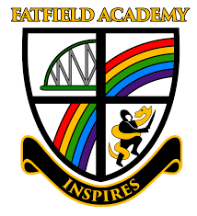

Careers Curriculum
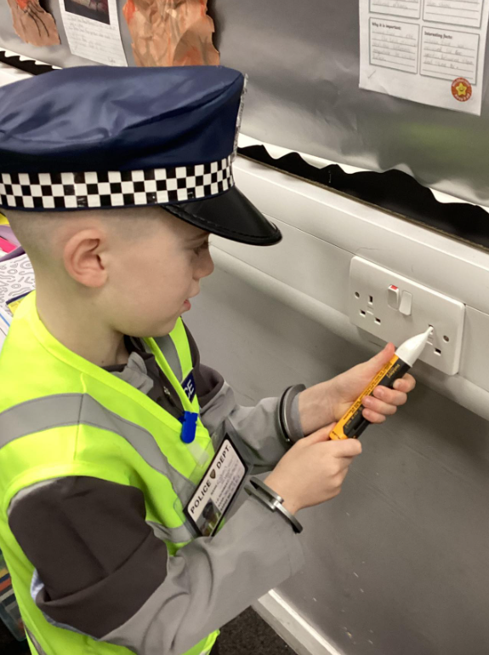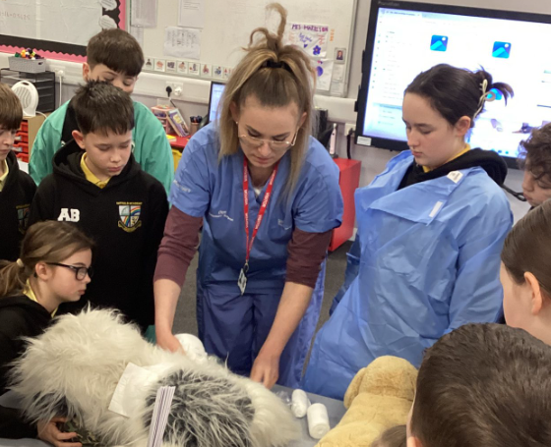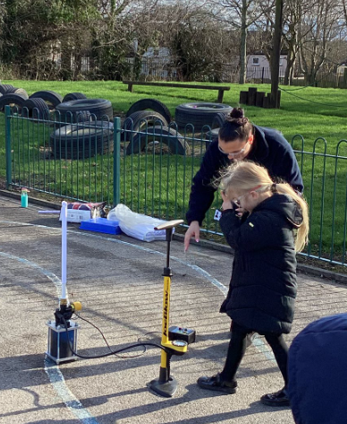




Our Vision:
At Fatfield Academy, every individual feels safe, supported and inspired to take risks and embrace challenge. Our curriculum, rich with wider experiences, develops secure knowledge and skills while developing independence and resilience. Children are actively encouraged to have high aspirations and leave us equipped to achieve their dreams and develop a passion for lifelong learning.

We know that even at the young age of three or four, children are already starting to form their first aspirations. By six they are starting to have opinions on what they think they can or can’t do in the future. By the time they’re 10, young people start to make decisions which could go on to limit their future options.
At Fatfield Academy, we believe it is important that children begin to develop an understanding of the wider world and the opportunities available to them in the future. Through our curriculum and enrichment experiences, we aim to broaden pupils’ horizons, raise aspirations and help them develop the knowledge, skills and attitudes that will support their future success.
Our aim is not for children to decide on a future career at a young age. Instead, we want pupils to be curious about the world around them and to understand that there are many different pathways and possibilities available. By introducing children to a wide range of roles, industries and real-life experiences, we help them begin to see how learning in school connects to life beyond the classroom.
At Fatfield Academy, pupils develop key personal qualities such as confidence, resilience, independence and teamwork, alongside essential skills in communication, problem solving and creativity. Through activities such as outdoor learning, Forest School experiences, community links and wider curriculum opportunities, children gain a growing understanding of the world of work and the skills that help people
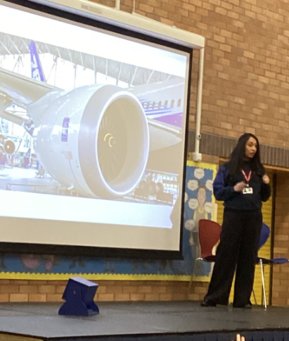
succeed.
By the time our pupils leave Fatfield, we want them to feel confident, inspired and ambitious, with a broad understanding of the many opportunities available to them and the knowledge that their learning today can help shape their future.

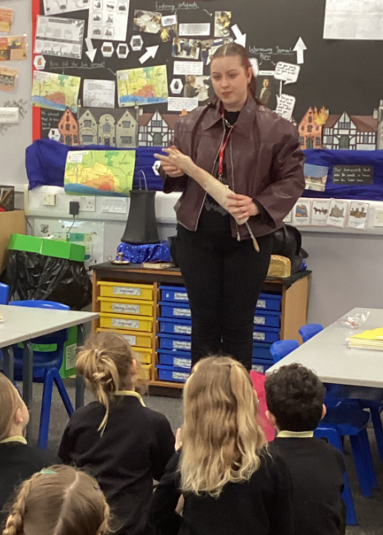
The Gatsby Benchmarks are a set of eight guidelines that help schools provide high-quality careers education for pupils. Developed by the Gatsby Charitable Foundation and used across schools in England, they support children in learning about the world of work, different career opportunities and the skills they will need in the future. Following these benchmarks helps ensure that pupils gain the knowledge, experiences and aspirations that will prepare them for their next stages of education and life beyond school.

What do the Gatsby Benchmarks look like at Fatfield Academy?

A stable careers programme (GB1) | At Fatfield Academy, this is carefully planned and delivered through our PSHE/RSE curriculum, as well as our wider enrichment offer, which enhances our curriculum and helps to raise aspirations for all pupils. Children benefit from a range of experiences including visits, visitors, themed days and real-life learning opportunities that introduce them to the world of work in an age-appropriate way.  In addition, assemblies play a key role in developing pupils’ understanding of future possibilities. Through whole-school assemblies, we introduce children to different careers, celebrate achievements, explore key skills such as resilience and teamwork and invite visitors to share their experiences.  Further information about how we support pupils’ aspirations and experiences can be found on our school website and Facebook page.
Learning from career and labour market information (GB2) | We develop pupils’ understanding of careers and the wider labour market in an age-appropriate and meaningful way. We ensure that children begin to recognise that there are many different jobs and opportunities available to them, both locally and beyond, and that learning in school links to future possibilities. This is made explicit during our Careers Week when we showcase a range of Washington businesses.  Through our curriculum, enrichment activities and assemblies, pupils are introduced to a wide range of roles and sectors. We make links to our local area and community, helping children to understand the types of jobs available in the North East, as well as broadening their awareness of opportunities nationally and globally.  Children learn about the skills, qualities and attitudes needed in different jobs, such as teamwork, resilience and communication, and begin to understand that there are different pathways into work, including further education, apprenticeships and training. This is supported through visitors, themed learning, real-life contexts and discussions, helping pupils to build curiosity, raise aspirations and see the relevance of their learning for the future.
Addressing the needs of each pupil (GB3) | We are committed to ensuring that every pupil can see themselves reflected in their learning and feel inspired to succeed. Our curriculum is carefully designed to reflect the diversity of our school community and the wider world. It is appropriately adapted so that all pupils can access, engage with and succeed in their learning.  We provide a range of pupil leadership opportunities in school including our OPAL maintenance Team, Kindness Crew, Sports Ambassadors, Librarians, Tuck Shop Leaders, Corridor Monitors, Technicians, Eco Warriors and School Council. This enables children to develop confidence, responsibility and a sense of belonging. Through these groups, pupils have a voice in school life and contribute to decision-making, helping to build key skills for the future.  We also ensure that pupils learn about a wide range of diverse role models, including individuals who have overcome barriers to achieve success in their chosen careers. This helps children to understand that background or circumstance should not limit ambition and encourages them to develop high aspirations, resilience and belief in their own potential.
Linking curriculum learning to careers (GB4) | We make clear links between learning and future careers across the curriculum. Children are encouraged to think like a historian, investigate like a scientist, write like an author and reason like a mathematician. This helps them to understand how different subjects connect to real-life roles and industries.  Our hall display, which we refer to during assemblies, reinforces these links by showcasing how a love of a subject can lead to a wide range of career opportunities. Through purposeful discussions and carefully planned learning experiences, pupils begin to see the relevance of what they are learning and how the knowledge and skills they develop in school can be applied in the wider world.
Encounters with employers and employees (GB5) | We provide pupils with meaningful opportunities to meet and learn from a range of employers and employees. Our annual Careers Week includes workshops and talks led by members of our wider school community and visitors from a variety of professions, helping children to gain first-hand insight into different roles.  We also organise educational visits, such as trips to Nissan, which allow pupils to see workplaces in action and understand how skills are used in real-life contexts. Throughout the year, pupils take part in additional workshops and sessions, including topics such as energy conservation, recycling, Little Lifesavers and sessions with the school nurse.  In addition, a display in school highlights former Fatfield pupils and their current pathways, helping children to see real-life examples of success and raising aspirations for their own futures.
Experiences of workplaces (GB6) | We provide pupils with meaningful experiences of workplaces through purposeful visits that are carefully linked to the curriculum. Details of these visits can be found in our pupil passport. These visits help children to see how their learning connects to real-life settings and different types of jobs.  During these experiences, pupils take part in careers-focused conversations, where they learn about roles within the workplace, the skills required and possible pathways into those careers. This helps to deepen their understanding and make the experiences more meaningful.
Encounters with further and higher education (GB7) | At Fatfield Academy, we have visits to feeder secondary schools and these staff also visit the children within our school setting. We are also developing links with Sunderland University.
Personal guidance (GB8) | We support pupils to broaden their understanding of future pathways through age-appropriate personal guidance opportunities. During our annual Careers Week, children have the chance to speak directly with visitors from a wide range of careers and sectors.  These sessions allow pupils to ask questions, find out about different jobs, and learn about the routes individuals have taken after leaving school, including further education, apprenticeships and training. This helps pupils to begin to understand that there are many different pathways available and that their choices and interests can shape their future.



